**CHAPTER 1**

**Data Communications, Data Networks, and the Internet**

**Technological Advancement Driving Forces - 4**

**Average Downstream Traffic (data) per Internet Subscriber (kbps) - 5**

**Notable trends - 6**

* **Trend toward faster and cheaper, in both computing and communication**
* **Today’s networks are more “intelligent”**
* **The internet, the web, and associated applications have emerged as dominant features for both business and personal network landscapes**
* **Mobility**

**Ethernet demand trend (Ethernet data rate standard) - 7**

**Changes in Networking Technology - 8**

**Emergence of High-Speed LANs - 9**

**Corporate Wide Area Networking Needs - 10**

**Digital electronics - 11**

**Convergence - 12**

**Communications model - 13 / 15**

**Communications tasks - 14**

**Transmission lines** (basic building block of any **-16**

communications facility is the transmission line)

**Transmission mediums** (fiber optic & wireless) **- 17**

**Transmission services** (multiplexing & compression) **- 18**

**Networks / Networking**  **- 19 - 20**

**Wide Area Networks (WANs)**  **- 21 - 22**

* **Circuit switching (23)**
* **Packet switching (24)**
* **Frame relay (25)**
* **Asynchronous Transfer Mode (ATM) (26)**

**Local Area Networks (LAN)** **- 27**

* Smaller scope, typically a single building
* LANs are usually owned by the same organization that owns attached devices
* Internal data rates greater than WANs
* Most common configurations are switched LANs and wireless LANs

**The internet**  **- 28**

**Key elements of the internet - 29**

**Simplified view of portion of internet - 30**

**Internet terminology**  **- 31**

**Networking configuration**  **- 32**

**CHAPTER 2**

**Protocol Architecture, TCP/IP, and Internet-Based Applications**

**The need for a protocol architecture (to transfer data tasks must be performed:) - 4**

1. **The source mush either activate the direct communications path or inform the network of the identity of the desired destination system.**
2. **The source system must ascertain that the destination system is prepared to receive data.**
3. **The file transfer application on the source system must ascertain that the file management program on the destination system is prepared to accept and store the file for this particular user.**
4. **A format translation function may need to be performed by one or the other system if the file formats used on the two systems are different.**

**Functions of protocol architecture - 5**

**Key Features of a Protocol - 6**

* **Syntax –** format of data blocks
* **Semantics –** Control information for coordination and error handling
* **Timing –** Speed matching and sequencing

**Communication Layers - 8**

**Protocol Architectures and Networks - 9**

**Protocols in a Simplified Architecture - 10**

**TCP/IP Protocol Architecture - 11**

**TCP/IP Layers and Example Protocols - 12**

**Physical Layer - 13**

**Network Access/Data Link Layer - 14**

**Internet Layer - 15**

**Host-to-Host (Transport) Layer - 16**

**Application Layer - 17**

**TCP/IP Concepts - 18**

**TCP/IP Address Requirements - 19**

**Protocol Data Units (PDUs) in the TCP/IP Architecture - 20**

**Transmission Control Protocol (TCP) - 21**

**TCP and PDU Headers - 22**

**User Datagram Protocol (UDP) - 23**

**IPv4 Header - 24**

**IPv6 Header - 25**

**Some Protocols in the TCP/IP Protocol Suite - 26**

**Protocol Architecture as a Framework for Standardization - 27**

**Service Primitives and Parameters - 28**

**Service Primitive Types - 29**

* **REQUEST**
* **INDICATION**
* **RESPONSE**
* **CONFIRM**

**Time Sequence Diagrams for Service Primitives - 30**

**Traditional Internet-Based Applications - 31**

**Multimedia Terminology - 32**

**Multimedia Taxonomy - 33**

**Media Types - 34**

* **Audio**
* **Image**
* **Video**
* **Text**

**Domains of Multimedia Systems and Example Applications - 35**

**Multimedia Applications - 36**

**Multimedia Technologies - 37**

* **Compression (**JPG – images / MPG – videos**)**
* **Communications/Networking (**Refers to the transmission and networking technologies that can support high-volume multimedia traffic**)**
* **Protocols (**RTP / SIP**)**
* **Quality of service (QoS) (**Can deal with priority, delay constraints, delay variability constraints, and other similar requirements**)**

**CHAPTER 3**

**Data Transmission**

**Transmission Terminology - 4 - 6**

**Analog and Digital Waveforms - 7**

**Examples of Periodic signals (Sine wave and Square wave) - 8**

**Sine wave s(t) = A sin(2πft + f) - 9 - 10**

**Wavelength (λ) - 11**

**Frequency Domain Concepts - 12**

**Addition of Frequency Components (T = 1/f) - 13**

**Frequency- Domain Representations - 14**

**Spectrum and Bandwidth - 15**

* **Spectrum –** Range of frequencies contained in signal
* **Absolute bandwidth –** Width of spectrum
* **Effective bandwidth (or just bandwidth) –** Narrow band of frequencies containing most energy
* **Dc component –** Component of zero frequency

**Signal with dc Component - 16**

**Data Rate and Bandwidth - 17**

**Frequency Components of Square Wave (T = 1/f) - 18**

**Analog and Digital Data Transmission - 19**

* **Data –** Entities that convey information
* **Signals –** Electric or electromagnetic representations of data
* **Signaling –** Physical propagation of the signal along a suitable medium
* **Transmission –** Communication of data by the propagation and processing of signals

**Acoustic Spectrum of Speech and Music [CARN99] - 20**

**Digital data - 21**

* **Text**
* **Character strings**
* **IRA**

**Attenuation of Digital Signals - 22**

In physics, attenuation or, in some contexts, extinction is the gradual loss of flux intensity through a medium. For instance, dark glasses attenuate sunlight, lead attenuates X-rays, and water and air attenuate both light and sound at variable attenuation rates.

**Advantages and Disadvantages of Digital Signals - 23**

* **Advantages –** Generally cheaper / Less susceptible to noise interference
* **Disadvantages –** Suffer more from attenuation

**Conversion of Voice Input to Analog Signal - 24**

**Video signals - 25**

**Conversion of PC input to Digital Signal - 26**

**Analog and Digital Signaling of Analog and Digital Data - 27**

**Analog and Digital Transmission - 28**

**Move to Digital - 29**

* **Digital technology**
* **Data integrity**
* **Capacity utilization**
* **Security and privacy**
* **Integration**

**Asynchronous and Synchronous Transmission - 30**

**Transmission Impairments - 31**

**Attenuation - 32**

**Attenuation and Delay Distortion Curves for a Voice Channel - 33**

**Delay Distortion - 34**

**Noise - 35**

* **Thermal noise (36)**
* **Intermodulation noise (36)**
* **Crosstalk (37)**
* **Impulse noise (37)**

**Channel Capacity - 38**

* **Data rate -** The rate, in bits per second (bps) at which data can be communicated
* **Bandwidth -** The bandwidth of the transmitted signal as constrained by the transmitter and the nature of the transmission medium, expressed in cycles per second, or hertz. **The greater the bandwidth of a facility, the greater the cost**
* **Noise** - The average level of noise over the communications path. **The main constraint on achieving efficiency is noise**
* **Error rate** - The rate at which errors occur, where an error is the reception of a 1 when a 0 was transmitted or the reception of a 0 when a 1 was transmitted

**Nyquist Bandwidth - 39**

**Shannon Capacity Formula - 40**

**Spectral Efficiency versus SNR - 41**

**CHAPTER 3 EXAMPLES**

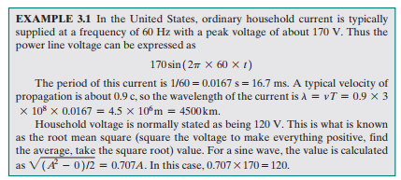

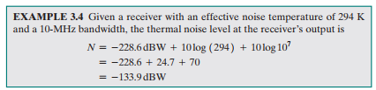

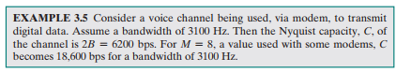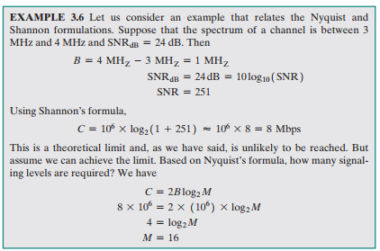

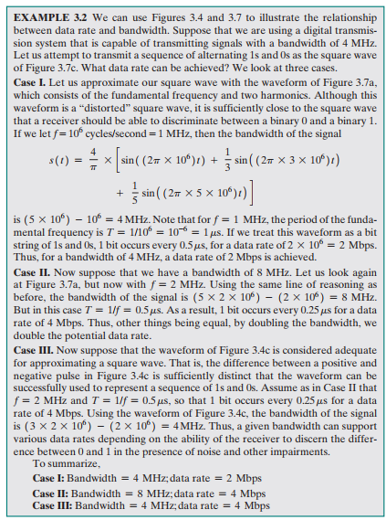

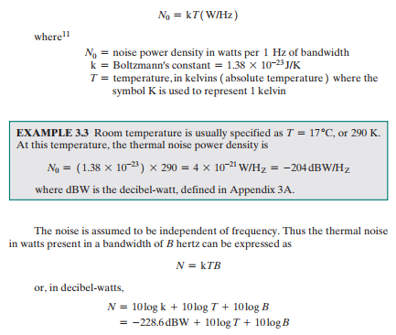

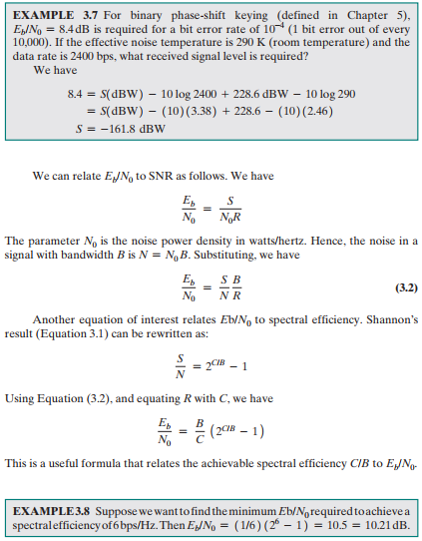

**CHAPTER 4**

**Transmission Media**

**Design Factors Determining Data Rate and Distance - 4**

* **Bandwidth –** Higher bandwidth gives higher data rate
* **Transmission impairments –** Impairments, such as attenuation, limit the distance
* **Interference –** Overlapping frequency bands can distort or wipe out a signal
* **Number of receivers –** More receivers introduces more attenuation

**Electromagnetic Spectrum for Telecommunications - 5**

**Point-to-Point Transmission Characteristics of Guided Media - 6**

**Guided Transmission Media - 7**

**Twisted Pair - 8**

**Attenuation of Typical Guided Media - 9**

**Unshielded (UTP) and Shielded Twisted Pair (STP) - 10**

**Twisted Pair Categories and Classes - 11**

**Near-End Crosstalk (NEXT) - 12**

**Signal Power Relationships (from System A viewpoint) - 13**

**Category 6A Channel Requirements - 14**

**Coaxial Cable - 15**

**Coaxial Cable – Transmission Characteristics (analog / digital signals) - 16**

**Attenuation of Typical Guided Media - 17**

**Optical Fiber - 18**

**Optical Fiber – Benefits - 19**

* **Greater capacity**
* **Smaller size and lighter weight**
* **Lower attenuation**
* **Electromagnetic isolation**
* **Greater repeater spacing**

**Optical fiber Categories of Application - 20**

* **Long-haul trunks**
* **Metropolitan trunks**
* **Rural exchange trunks**
* **Subscriber trunks**
* **Local area networks**

**Optical Communication - 21**

**Optical Fiber Transmission Modes - 22**

**Frequency Utilization for Fiber Applications - 23**

**Attenuation in Guided Media - 24**

**Wireless Transmission Frequencies - 25**

* **1GHz to 40GHz** 
  + Referred to as microwave frequencies
  + Highly directional beams are possible
  + Suitable for point to point transmissions
  + Also used for satellite communications
* **30MHz to 1GHz** 
  + Suitable for omnidirectional applications
  + Referred to as the radio range
* **3x1011 to 2x1014** 
  + Infrared portion of the spectrum
  + Useful to local point-to-point and multipoint applications within confined areas

**Antennas - 26**

**Radiation Pattern (isotropic antenna?) - 27**

**Parabolic Reflective Antenna - 28**

**Antenna Gain - 29**

* A measure of the directionality of an antenna
* Defined as the power output in a particular direction versus that produced by an isotropic antenna
* Measured in decibels (dB)
* The increased power radiated in a given direction is at the expense of other directions
* Effective area of an antenna is related to the physical size of the antenna and to its shape

**Terrestrial Microwave - 30**

* Most common type is the parabolic “dish”
* Typical size is about 3 m in diameter
* Antenna is fixed rigidly and focuses a narrow beam to achieve line-of-sight transmission to the receiving antenna
* Usually located at substantial heights above ground level
* A series of microwave relay towers is used to achieve long-distance transmission

**Terrestrial Microwave Applications - 31**

**Typical Digital Microwave Performance - 32**

**Satellite Microwave - 33**

**Satellite Communication Configurations - 34**

**Satellite Microwave Applications - 35**

**Typical VSAT Configuration - 36**

**Transmission Characteristics - 37**

**Broadcast Radio - 38**

**Infrared - 39**

**Frequency Bands - 40**

**Ground-wave propagation (below 2MHz) - *Wireless Propagation Modes* - 41**

**Sky-wave propagation (2 to 30MHz) – *Wireless Propagation Modes* - 42**

**Line-of-sight (LOS) propagation (above 30MHz) - *Wireless Propagation Modes* - 43**

**Refraction - 44**

**Optical and Radio Horizons - 45**

**Line-of-Sight Transmission - 46**

**Free Space Loss - 47**

**Examples of Multipath Interference - 48**